***AWS tutorials***

Amazon web services allows you to sign up for an AWS account. The free account allows you to use several services for free. Details of the services that an AWS account user can use for free and any additional charges that can be incurred can viewed in the following link: <http://aws.amazon.com/free/>

After you create an account and sign into AWS you could see the console as below:

tt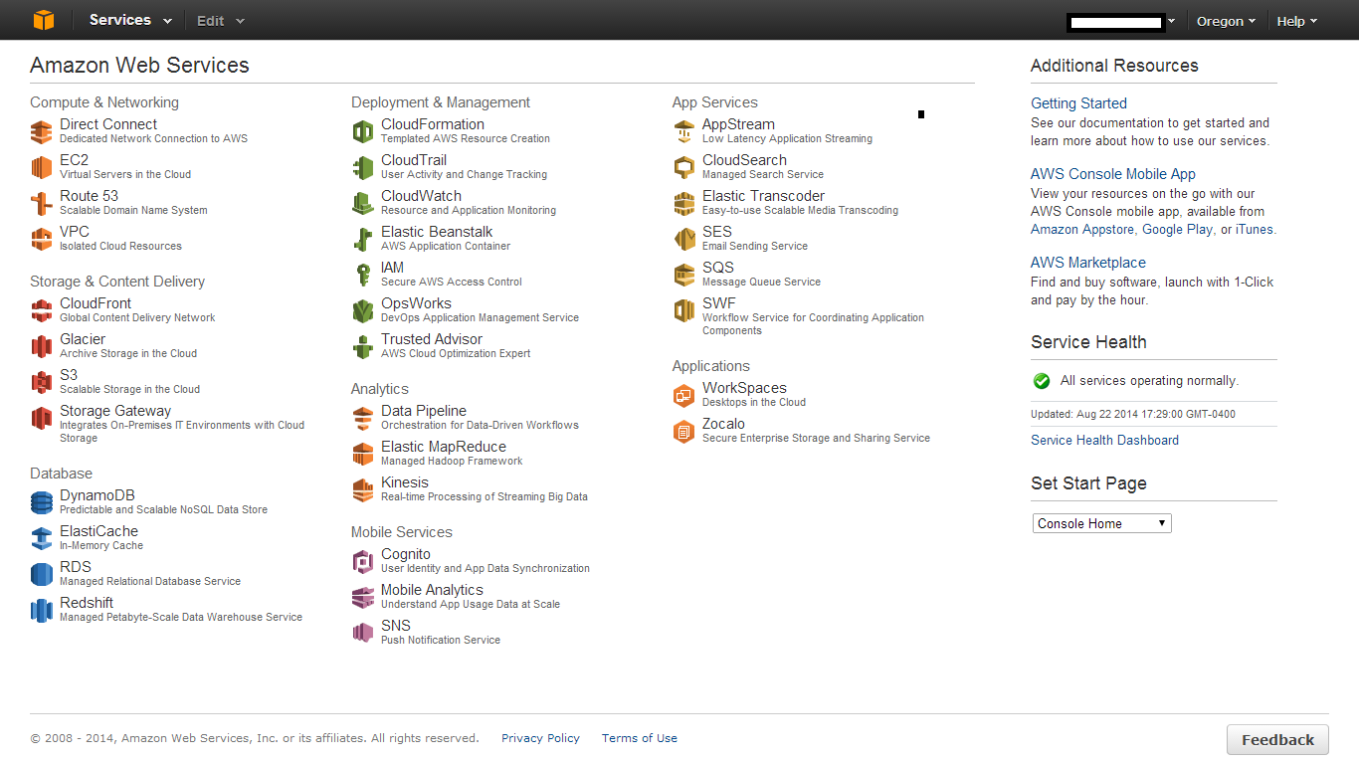

To begin learning about AWS services, Amazon provides a getting started link on the right hand side in additional resources to gain an understanding of how to use the AWS services. <http://aws.amazon.com/documentation/gettingstarted/>

The above links provides tutorials such as:

* Getting started with AWS
* AWS management console
* AWS computing basics for linux
* AWS computing basics for windows
* AWS web application hosting
* Deploying a web application
* Analyzing big data with AWS
* AWS static web site hosting

You could find the entire list of AWS tutorials which is maintained and updated entirely by Amazon. <http://aws.amazon.com/resources/>

The links has all the documentation for

1. Documentation for Amazon web serices
2. Amazon machine images (that can be used to spin up new EC2 instances with prepackaged software)
3. Analyst reports
4. Public data sets (centralized repository that can be integerated into your cloud based applications)
5. Sample code and libraries available to the developers
6. AWS certification
7. AWS training
8. Sample code and libraries
9. User groups
10. Developer groups

A few basic tutorials to get started with if you are new AWS

1. Amazon Elastic Cloud compute(EC2) - <http://aws.amazon.com/ec2/>

<http://docs.aws.amazon.com/AWSEC2/latest/UserGuide/EC2_GetStarted.html>

1. Amazon Elastic Blast storage(EBS) – <http://docs.aws.amazon.com/AWSEC2/latest/UserGuide/ebs-attaching-volume.html>
2. Amazon s3 bucket - <http://docs.aws.amazon.com/AmazonS3/latest/gsg/GetStartedWithS3.html>

<http://aws.amazon.com/s3/>

1. Use Amazon EBS with EC2 instance - <http://docs.aws.amazon.com/AWSEC2/latest/UserGuide/ebs-attaching-volume.html>
2. Amazon Virtual private cloud (VPC) - <http://aws.amazon.com/documentation/vpc/>

<http://docs.aws.amazon.com/AmazonVPC/latest/UserGuide/VPC_Introduction.html>

1. Amazon Dynamo DB - <http://aws.amazon.com/dynamodb/>

<http://docs.aws.amazon.com/amazondynamodb/latest/developerguide/GettingStartedCreateTables.html>

1. Amazon RDS - <http://docs.aws.amazon.com/AmazonRDS/latest/UserGuide/CHAP_GettingStarted.html>
2. Amazon Cloud watch, metrics and alarms - <http://aws.amazon.com/documentation/cloudwatch/>

<http://docs.aws.amazon.com/AWSEC2/latest/UserGuide/using-cloudwatch.html>

<http://docs.aws.amazon.com/AmazonCloudWatch/latest/DeveloperGuide/working_with_metrics.html>

1. Amazon identity and access management(IAM)

<http://aws.amazon.com/documentation/iam/>

<http://docs.aws.amazon.com/IAM/latest/UserGuide/IAMBestPractices.html>

1. Amazon Command line tools(CLI)

<http://docs.aws.amazon.com/AmazonRDS/latest/CommandLineReference/StartCLI.html>

<http://aws.amazon.com/cli/>

1. Amazon security credentials

<http://docs.aws.amazon.com/general/latest/gr/aws-security-credentials.html>

AWS SDK for JAVA - <https://aws.amazon.com/articles/3586>

AWS SDK for PHP - <https://aws.amazon.com/articles/4261>

Additional links:

<http://aws.amazon.com/training/intro_series/>

<http://aws.amazon.com/training/course-descriptions/essentials/>